# Name : Diya

# Sap Id: 500107068

# Batch : 26

**Ques 1:**

Consider a queue given below which has front=1 and rear=5 elements are a,b,c,d,e . Perform foolo op on queue

Add f

Delete two letters

Add g

Add h

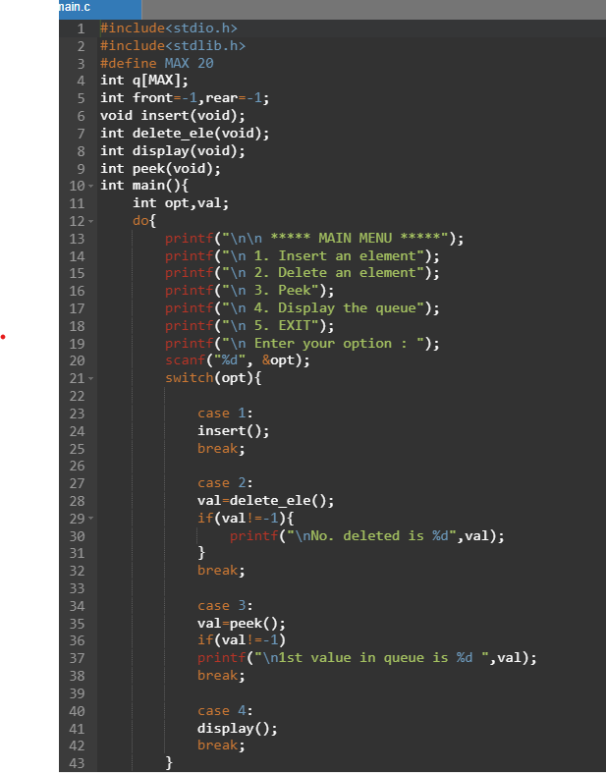

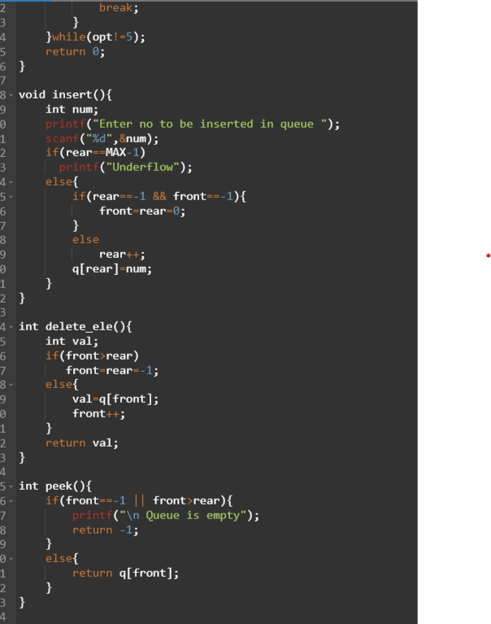

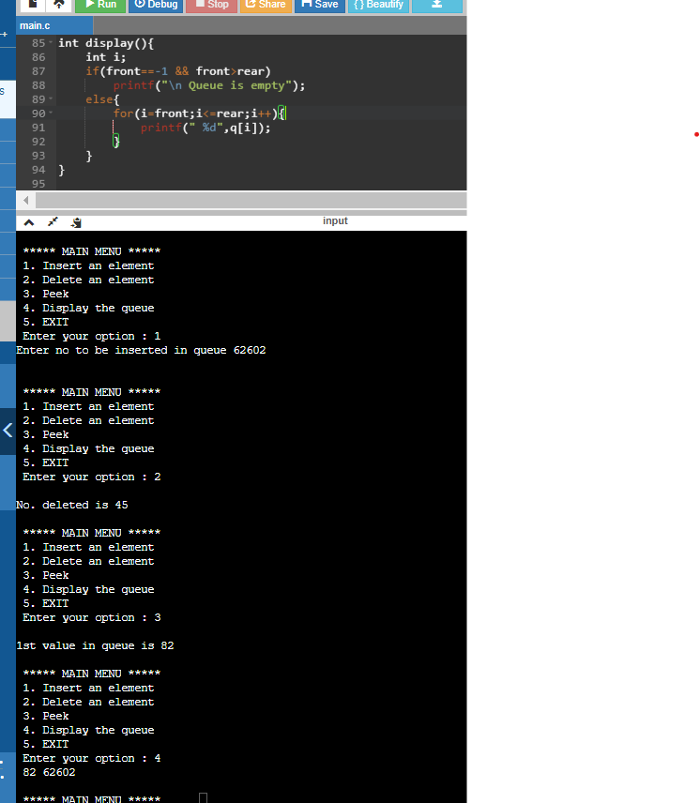

**Ques 2:**

WAP to reverse the elements of a queue

**Ques 3:**

WAP to input 2 queue and compare their contents